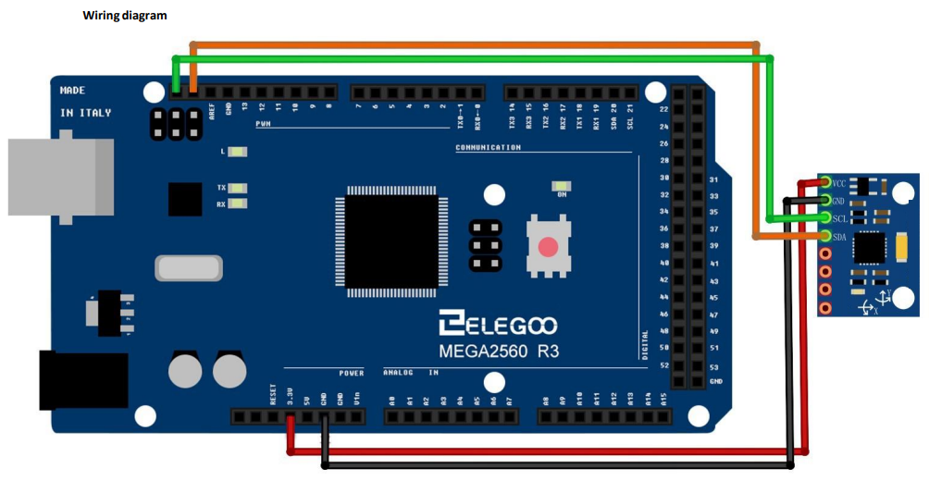
#include <Wire.h>

// MPU-6050 I2C address
const int MPU_addr = 0x68;

// Gyroscope and accelerometer vars
int16_t AcX, AcY, AcZ, GyX, GyY, GyZ;
float gyroX, gyroY, gyroZ; // Angular velocity in °/s
float accX, accY, accZ; // Accelerometer data in g

// Orientation variables
float roll, pitch, yaw; // Roll, pitch, and yaw angles
//Note: Dependent on how the sensor is place affects these (roll and pitch are switched currently)
float rollAcc, pitchAcc; // Roll and pitch from accelerometer

// Complementary filter variables
float alpha = 0.98; // Weight for gyroscope data (tune this value if needed)

// Timing variables
float dt; // Time interval
unsigned long prevTime; // Previous time stamp

// Gyroscope sensitivity scale factor (for ±250°/s range)
const float GYRO_SCALE = 131.0;

// Accelerometer sensitivity scale factor (for ±2g range)
const float ACCEL_SCALE = 16384.0;

void setup() {
Wire.begin();
Serial.begin(9600);

// Initialize MPU-6050
Wire.beginTransmission(MPU_addr);
Wire.write(0x6B); // PWR_MGMT_1 register
Wire.write(0); // Wake up the MPU-6050
Wire.endTransmission(true);

// Initialize variables
roll = 0;
pitch = 0;
yaw = 0;
prevTime = micros();
}

void loop() {
// Read accelerometer and gyroscope data
Wire.beginTransmission(MPU_addr);
Wire.write(0x3B); // Start with register 0x3B (ACCEL_XOUT_H)
Wire.endTransmission(false);
Wire.requestFrom(MPU_addr, 14, true); // Request 14 registers

// Read accelerometer data
AcX = Wire.read() << 8 | Wire.read();
AcY = Wire.read() << 8 | Wire.read();
AcZ = Wire.read() << 8 | Wire.read();

// Read temperature data (not used in this example)
Wire.read() << 8 | Wire.read();

// Read gyroscope data
GyX = Wire.read() << 8 | Wire.read();
GyY = Wire.read() << 8 | Wire.read();
GyZ = Wire.read() << 8 | Wire.read();

// Convert raw accelerometer data to g
accX = AcX / ACCEL_SCALE;
accY = AcY / ACCEL_SCALE;
accZ = AcZ / ACCEL_SCALE;

// Convert raw gyroscope data to °/s
gyroX = GyX / GYRO_SCALE;
gyroY = GyY / GYRO_SCALE;
gyroZ = GyZ / GYRO_SCALE;

// Calculate time interval
unsigned long currentTime = micros();
dt = (currentTime - prevTime) / 1000000.0; // Convert to seconds
prevTime = currentTime;

// Calculate roll and pitch from accelerometer
rollAcc = atan2(accY, accZ) * 180 / PI;
pitchAcc = atan2(-accX, sqrt(accY * accY + accZ * accZ)) * 180 / PI;

// Apply complementary filter to combine gyroscope and accelerometer data
roll = alpha * (roll + gyroX * dt) + (1 - alpha) * rollAcc;
pitch = alpha * (pitch + gyroY * dt) + (1 - alpha) * pitchAcc;
yaw += gyroZ * dt; // Yaw is only from gyroscope (no accelerometer correction)

// Print orientation
Serial.print("Pitch: ");
Serial.print(roll);
Serial.print(" | Roll: ");
Serial.print(pitch);
Serial.print(" | Yaw: ");
Serial.println(yaw);

delay(10); // Small delay for stability
}

